**LEVEL. A1**

**VERBS + TO + INFINITIVE AND VERBS + -ING**

***VERBS + -ING***

*Some verbs in English are followed by another verb in the -ing form.*

*The most common of these verbs are verbs of liking and disliking****: love, like, enjoy, don’t mind, don’t like, hate, mind, stop, finish, suggest***

*If we use another verb after these verbs, it* ***often*** *takes the -ing form.*

*I love going to the gym.*

*I like reading.*

*I enjoy travelling.*

*I don’t mind cooking.*

*I don’t like doing homework.*

*I hate getting up early.*

*Has it stopped raining?*

*Sonia suggested going to the cinema.*

*The* ***second******verb*** *is in the -****ing*** *form in the* ***past*** *too.*

*When I was a child I hated going to school. (NOT ~~I hated went to school~~.)*

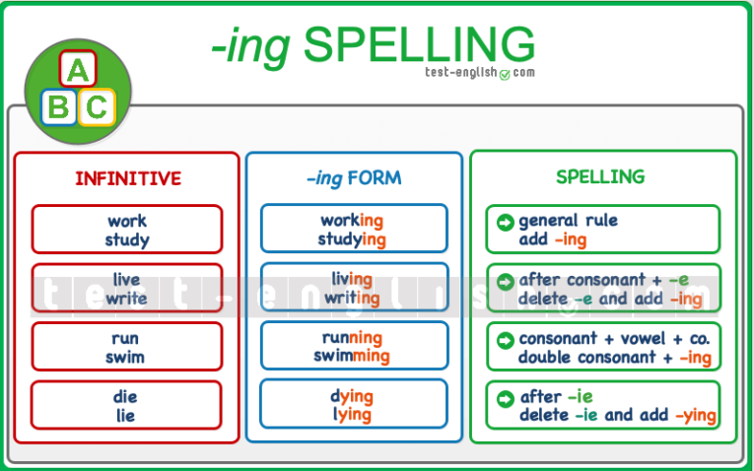***-ing spelling***

***VERBS + TO + INFINITIVE***

***Many*** *verbs in English are followed by to + infinitive.*

*Some of these verbs are:* ***forget, hope, learn, need, offer, plan, remember, start, want, would like****,* ***need, plan, expect, promise, decide, refuse, try:***

*I forgot to turn off the light.*

*I hope to see you soon.*

*I‘m learning to drive.*

*We need to arrive early.*

*She offered to help us.*

*We are planning to go to France.*

*Remember to lock the door.*

*I want to go home.*

*I would like to buy a new computer.*

*The* ***second*** *verb takes the* ***to*** *+ infinitive form in the* ***past*** *too.*

*I wanted to go home. (NOT ~~I wanted to went home~~.)*

***VERBS + -ING OR TO ...***

***Like, prefer, love, hate, start, begin, continue +*** *-ing (doing etc.) or to ... (to do etc.)*

*Do you like getting up early? or Do you like to get up early?*

*I prefer travelling by car. or I prefer to travel by car.*

*Anna loves dancing, or Anna loves to dance.*

*I hate being late, or I hate to be late.*

*It started raining, or It started to rain.*

***WOULD LIKE***

*The verb* ***would like*** *(or ‘****d like****) is different from* ***like****. We use* ***would like + to + infinitive*** *and we* ***normally*** *use* ***like + -ing*** *verb to talk about general preference.*

*I‘d like to study English.*

*I like studying English.*

*The meaning is also different:*

*I‘d like to study English. (===I want to do it.)*

*I like studying English. (===I enjoy it.)*

*We use the question* ***would you like****… when we offer or suggest something:*

*Would you like a cup of coffee?*

*Would you like to dance with me?*